UP BikeShare Web App
Analysis Model

Submitted to:

Prof. Ma. Rowena C. Solamo
Faculty Member
Department of Computer Science
College of Engineering
University of the Philippines, Diliman

Submitted by:
Kevin Fernandez
Paul Ongoco
John Prudente

In partial fulfillment of Academic Requirements
for the course
CS 191 Software Engineering I
of the
1st Semester, AY 2015-2016

Revision Control

History Revision:
Revision Date | Person Responsible | Version  Number | Modification
12/13/15 | Kevin Fernandez | 1.0 | Initial Document; Added Login/register/bike diagrams

System Name: UP BikeShare

Description: The UP BikeShare Web App must be able to cater to the BikeShare customers important features for use of the system. User must be able create an account, which will be the main interaction between the service and the customer. The usermust be able to search bikes in an area, as well as be able to reserve a bike if needed. The user must also be able to report bike issues, as well as other general concerns.

Class Diagram:

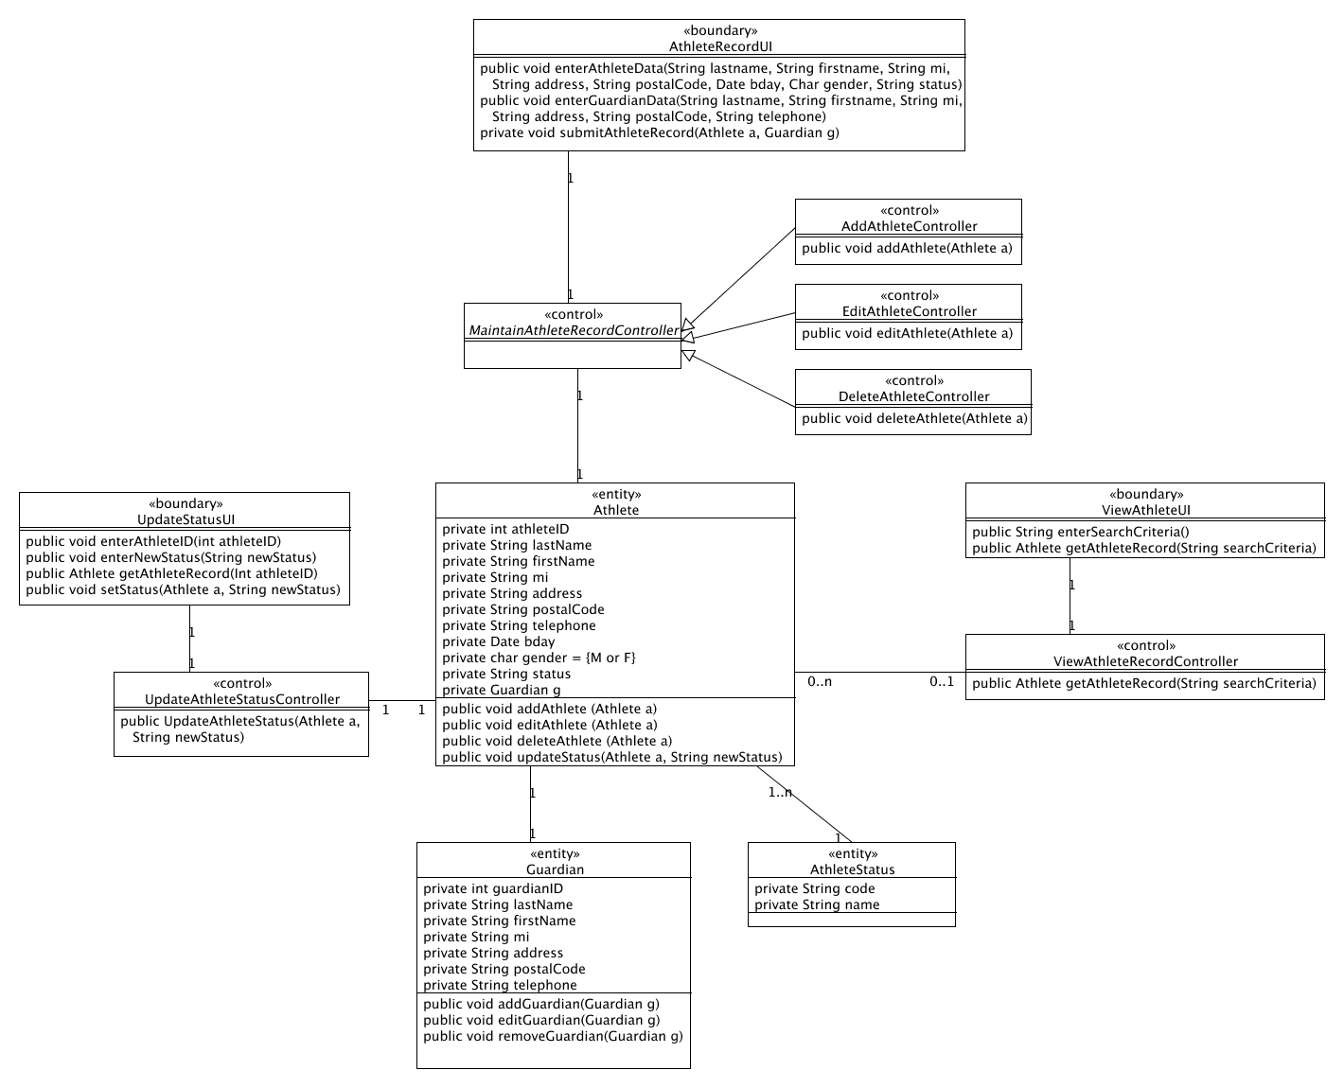

Boundary Classes:

Class Name | Description
LogInUI | Provides the UI for user login. Accepts username and password. Displays whether login was successful or not.
RegisterUI | Provides UI for account registration. Has fields for username and password, as well as other needed information for registration. Displays whether registration was successful or not.
ReserveBikeUI | Provides UI that displays the map where system is active. You can check locations, and reserve a bike reservation, or cancel it. Displays time remaining to cancel reservation.

Control Classes:

Class Name | Description
LoginController | Allows and verifies the user start his login session. Connects to the database.
RegisterController | Sends information for registration to the database.
ReserveBikeController | Connects the user information of reservation to the database. Updates bikes being reserved/cancelled. Also updates the time.

Entity Classes:

Class Name | Description
User | Customer of UP BikeShare. Has all information required by the database.
Bike | Bikes being used by the system. Has all information required by the database.

